Mobile Applications Development 2

# By Cormac Raftery G00348802

# Idea

My idea of a worthy application for this module is to build a gaming app with some really well known classical strategy games such as chess, checkers and minesweeper. The reason I think this would be a popular app is that due to the games similar target audience, anyone with one of these games on their phone tends to like all 3 so it would be convenient to have all 3 in one app. Growing up with these games I feel I know them well enough to be comfortable applying all the rules, except for perhaps some rules in chess which I will need to research to ensure I make every move possible.

# Plan

Initially I intend to open on the main page which will present three buttons for the user to select the game they would like to play which will then push the user to another page. I will then ask the user if they would like to load an existing game or start a new game. Upon selecting start a new game the user will be pushed to a new page depending on the game selected and start a new game. On this page I intend to have a back button and a button to save the game status on the top of each game for consistency in layout. The board will be generated under these buttons. The save button will allow you to enter a title to save your game under and store that game to my online database(probably mongoDB) ready to be loaded again.

# Chess & Checkers

I plan on starting off with checkers/draughts as it seems like it will be the easiest game to begin with and will give me a nice template to start chess with. Each piece will most likely be just images moving around an 8 by 8 grid so the “tricky” part will be checking for valid moves.

For my chess game I have researched online and I have found some AI examples but I feel player versus player will be sufficient for the project so I will programme each game for player versus player before I look deeper into AI capabilities.

# Minesweeper

For my minesweeper game I will have to add an extra option for difficulty so this game will have two separate pages if start a new game is selected. The mines will then be randomly generated around the grid and each grid square will be a button with a value of either mine or no mine and detect mines around it. I will also have to distinguish whether the user clicks or double clicks each tile as I plan to add the option to flag a square the user believes is a mine.

# Data Storage

Each game will be able to be stored in mongoDB under a title and loaded at a later date.

# Use of sensors

There will be different noises played as the user moves pieces or hits a mine and multi touch gestures will be used in minesweeper for planting a flag.

# App design

Main/home page upon opening the application you will be asked to select your game.

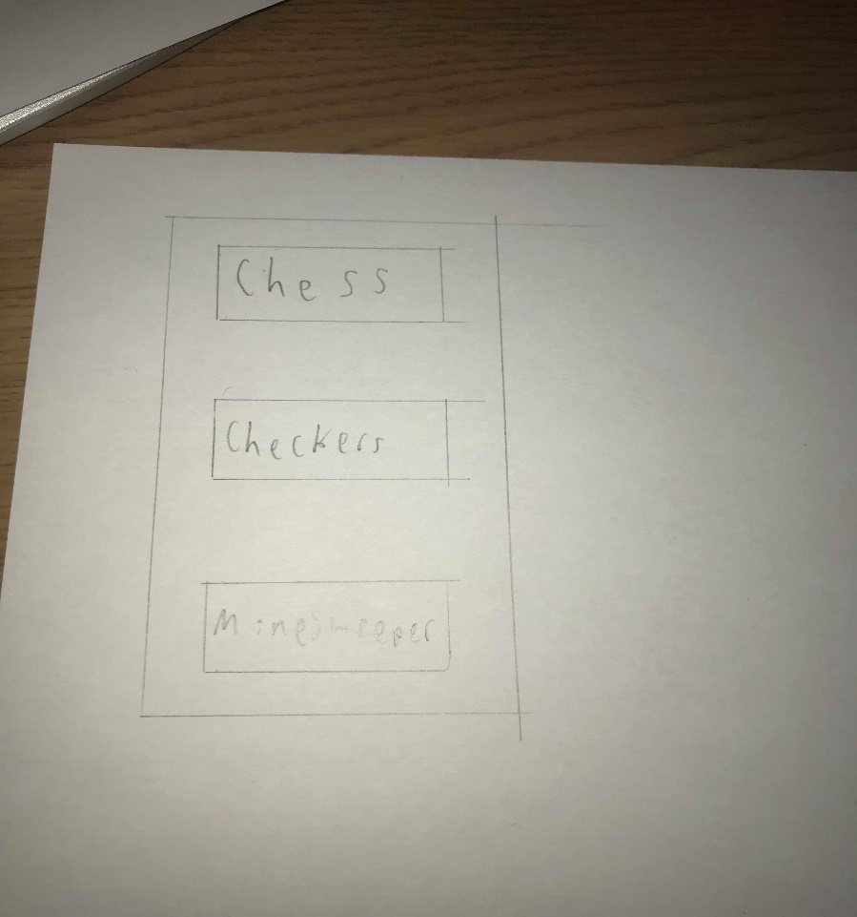

You will then be asked to choose whether you wish to start a new game or load a game.

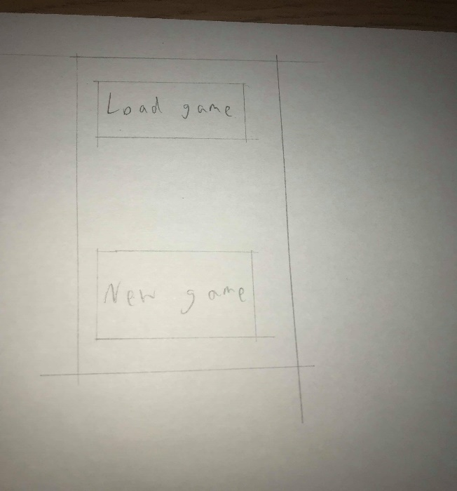

If you select load a game you will be presented with all of the saved games you have.

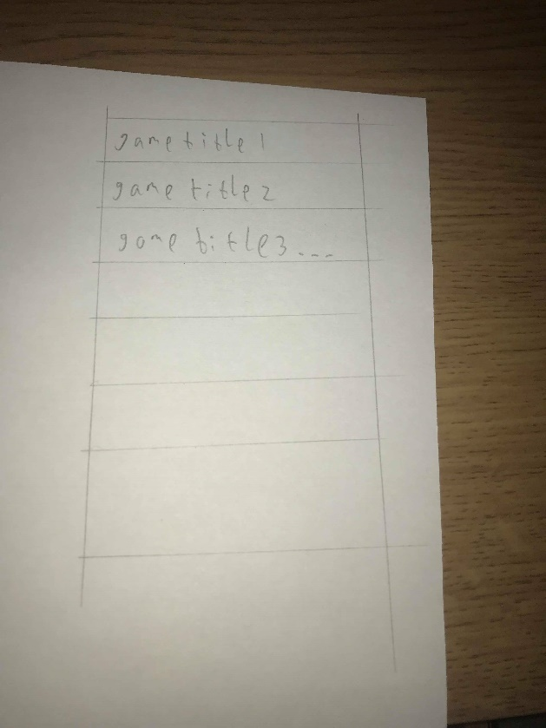

Each game will appear like this with a home button top left and a save button top right but the big grid will be different for each of the 3 games.

